

**E-commerce Website System**

A PROJECT REPORT

Submitted by

**BHUMI THAKAR**

UNDER THE SUPERVISION OF

GUIDE & LECTURER

**SUGANDH GUPTA**

JUN-JULY 2023

For Tops Technologies



**Chapter – 1: Overview of Company**

* 1. **About the Company**

**Name:** Tops Technologies

**Address:** 407, Mahadev Chowk, Dhara Arcade, opp. Swaminarayan temple, Maruti

Nandan Society, Mota Varachha, Surat, Gujarat 394101

**Website**:

**Phone no.:** +91

**About:**

Tops technologies is a company offering services in the field of Software Development, Website Development, Mobile App Development, Graphic Designing, Digital Marketing, Testing & QA, Bulk SMS & Hosting Provider and IT Consultancy. In Terms of Services, Designing and Coding. Services include customized Software Development, Website Development and Programming, Mobile App Development, Graphic Designing, Digital Marketing, Testing & QA, Bulk SMS & Hosting Provider and IT Consultancy and Maintenance. Company has a vast experience in development for Software/Web and Mobile Application. Our Processes are highly streamlined and proven to ensure fastest delivery of a high-quality solution at a reasonable cost. We understand our client's need and changes over period of time. We have expertise to accommodate changes at any stage of software lifecycle.

**Chapter – 2: Introduction**

E-commerce (electronic commerce or EC) is the buying and selling of goods and services, or the transmitting of funds or data, over an electronic network, primarily the internet. These business transactions occur either as business-to-business, business-to consumer, consumer-to-consumer or consumer-to-business.

E-commerce shops have become part of our daily lives. Technological advancement has

made it possible for people to sit in the convenience of their homes and still shop online

without going to a physical shop. Africans have also joined the trend of e-commerce

business, so this project is meant to design an eCommerce online shop so that the people in Ghana (Africa)will be able to purchase their goods and services online.

This project is mainly divided into two main categories: The Administrators and the

Customers/Users.

The store manager and the staff members operate as the administrators. They can add,

edit, update products or, delete products thus they able to change the names of products,

change prices and, add or remove products.

The customer can search for products selection, update the cart, remove products from

the cart and check out from the shop. The customer is also able to update his information such as names, address and other data.

The User is only able to browse the online shop and add a product to the cart. The user

is limited to the use of the shop.

**2.1 Importance of E-commerce Websites**

E-commerce websites have reshaped the traditional brick-and-mortar retail model by enabling businesses to reach a global customer base without physical limitations. Some key reasons why e-commerce websites are essential include:

a. Global Reach: E-commerce allows businesses to expand their reach beyond geographical boundaries and tap into a worldwide market, reaching potential customers 24/7.

b. Convenience: Consumers can shop anytime, anywhere, eliminating the need to visit physical stores. E-commerce websites provide a seamless and user-friendly shopping experience, enabling customers to browse, compare, and purchase products with ease.

c. Cost-Effectiveness: E-commerce eliminates the need for physical stores, reducing overhead costs associated with rent, utilities, and staffing. This cost-saving benefit can often be passed on to customers, resulting in competitive pricing.

d. Personalization: E-commerce platforms leverage customer data and analytics to personalize the shopping experience, providing tailored product recommendations and offers based on individual preferences and browsing history.

**2.2 Key Features of E-commerce Websites**

Successful e-commerce websites share common features that contribute to their effectiveness. Some prominent features include:

* Product CatLog
* Shopping Cart and Checkout.
* Payment Gateway Integration
* Inventory Management.
* Customer Reviews and Ratings

**2.3 Benefits for Businesses and Consumers**

E-commerce websites offer numerous benefits for both businesses and consumers:

* Benefits for Businesses
* Benefits for Consumers

E-commerce websites have reshaped the traditional brick-and-mortar retail model by enabling businesses to reach a global customer base without physical limitations. Some key reasons why e-commerce websites are essential include:

**2.4 Technology**

2.5.1 PYTHON

2.5.2 DJANGO

2.5.2 DBBROWSER(MySQL)

**2.4.1 PYTHON**

**Introduction with Python**

Python is a widely used general-purpose, high level programming language. It was created by Guido van Rossum in 1991 and further developed by the Python Software Foundation. It was designed with an emphasis on code readability, and its syntax allows programmers to express their concepts in fewer lines of code.

Python is a programming language that lets you work quickly and integrate systems more efficiently.

There are two major Python versions: Python 2 and Python 3. Both are quite different

**Why Python?**

Python is a popular programming language that is widely used in the development of web applications. It is easy to learn, has a large and active community, and is supported by a wealth of libraries and frameworks.

Here's a fun fact: Python is the top preferred language for data science and research. Since its syntax is easily understandable and adaptable, people with little-to-no development experience can easily learn Python and use it to manipulate data for research, reporting, predictable or regression analyses, and more.

**Features of Python**

1. Free and Open Source

2. Easy to code

3. Easy to Read

4. Object-Oriented Language

5. GUI Programming Support

6. High-Level Language

7. Extensible feature

8. Easy to Debug

9. Python is a Portable language

10. Python is an Integrated language

11. Interpreted Language

12. Large Standard Library

13. Dynamically Typed Language

14. Frontend and backend development

15. Allocating Memory Dynamically

**OOPS in Python**

• Class

• Objects

• Polymorphism

• Encapsulation

• Inheritance

• Data Abstraction

**Python Class**

A class is a collection of objects. A class contains the blueprints or the prototype from which the objects are being created. It is a logical entity that contains some attributes and methods.

**Python Objects**

The object is an entity that has a state and behaviour associated with it. It may be any real-world object like a mouse, keyboard, chair, table, pen, etc. Integers, strings, floating-point numbers, even arrays, and dictionaries, are all objects.

**Creating an Object**

The Python self

The Python __init__ Method

Creating a class and object with class and instance attributes

Creating Classes and objects with methods

Python Inheritance

**Types of Inheritance:**

Single Inheritance:

Multilevel Inheritance:

Hierarchical Inheritance:

Multiple Inheritance:

**Python Polymorphism**

Polymorphism in Python:

This code demonstrates the concept of inheritance and method overriding in Python classes. It shows how subclasses can override methods defined in their parent class to provide specific behaviour while still inheriting other methods from the parent class.

**Python Encapsulation**

Encapsulation is one of the fundamental concepts in object-oriented programming (OOP). It describes the idea of wrapping data and the methods that work on data within one unit. This puts restrictions on accessing variables and methods directly and can prevent the accidental modification of data. To prevent accidental change, an object’s variable can only be changed by an object’s method. Those types of variables are known as private variables.

**Data Abstraction**

It hides unnecessary code details from the user. Also, when we do not want to give out sensitive parts of our code implementation and this is where data abstraction came.

Data Abstraction in Python can be achieved by creating abstract classes.

**Python Function Declaration**

• Python Built-in Functions.

• Python Recursion Functions.

• Python Lambda Functions.

**Python Function Declaration**

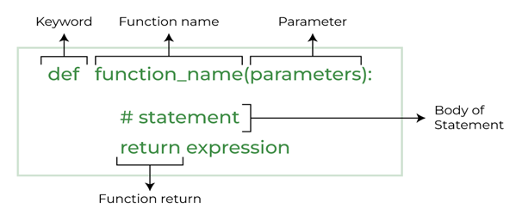

**2.5.2 DJANGO**

**What is Django?**

Django is a high-level web framework for building web applications using the Python programming language. It follows the Model-View-Controller (MVC) architectural pattern, which promotes the separation of concerns and the reusability of code.

Django provides a set of tools and libraries that simplify the process of building web applications. It includes an Object-Relational Mapping (ORM) layer, which allows developers to interact with databases using Python code, abstracting away the underlying database-specific details. This makes it easier to work with databases and switch between different database engines.

Django is a free and open source web application framework, written in Python. A web framework is a set of components that helps you to develop websites faster and easier.

When you're building a website, you always need a similar set of components: a way to handle user authentication (signing up, signing in, signing out), a management panel for your website, forms, a way to upload files, etc

**How It Works?**

Django works based on the Model-View-Controller (MVC) architectural pattern, although it refers to it as Model-View-Template (MVT) due to some differences in its implementation. Here's a high-level overview of how Django works:

• When a request comes to a web server, it's passed to Django which tries to figure out what is actually requested.

• It takes a web page address first and tries to figure out what to do. This part is done by Django's URL resolver (note that a website address is called a URL –Uniform Resource Locator – so the name URL resolver makes sense).

• It is not very smart – it takes a list of patterns and tries to match the URL. Django checks patterns from top to bottom and if something is matched, then Django passes the request to the associated function (which is called view).

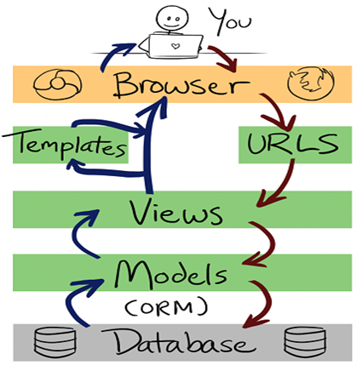

**Django Installation**

To install Django, you'll need to have Python already installed on your system. Here are the steps to install Django:

1. Open a command prompt or terminal window.

2. (Optional) It is recommended to create a virtual environment for your Django project to keep your project dependencies isolated. You can create a virtual environment by running the following command:

**python3 -m venv myenv**

Replace myenv with the name you want to give to your virtual environment.

3. Activate the virtual environment (if you created one). On Windows, the commandis:

**myenv\Scripts\activate**

On macOS and Linux, the command is:

**bash**

**source myenv/bin/activate**

4. Install Django by running the following command:

**pip install Django**

This will download and install the latest stable version of Django from the Python Package Index (PyPI).

5. Once the installation is complete, you can verify that Django is installed by running the following command:

**CSS**

**Django-admin --version**

It should display the version number of Django installed on your system.

Congratulations! Django is now installed on your system. You can start creating Django projects and applications by following the official Django documentation and tutorials. Remember to activate your virtual environment (if you created one) whenever you work on your Django project.

**2.5.2 DBBROWSER(MySQL)**

**What is MySQL Browser?**

The MySQL Query Browser is a graphical tool provided by MySQL AB for creating, executing, and optimizing queries in a graphical environment

MySQL Browser refers to a graphical user interface (GUI) tool that allows users to interact with MySQL databases visually. It provides an intuitive interface for managing and manipulating databases, tables, queries, and data within MySQL.

There are several popular MySQL browser tools available, including:

• MySQL Workbench

• phpMyAdmin:

• Navicat for MySQL

**Uses of SQLite Browser**

MySQL Browser, or a MySQL GUI tool, offers several uses and benefits for working with MySQL databases. Here are some common uses of MySQL Browser:

• Database Management:

• Data Manipulation

• Query Execution

• Visual Query Builders

• Data Visualization

• Database Administration

**How to Install MySQL browser?**

Step 1: Browse to the official MySQL Website.

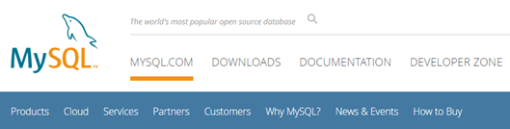

Step 2: There you will find the Download button.

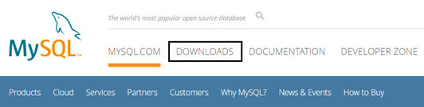

Step 3: Scroll down & click on MySQL Community (GPL) Downloads.

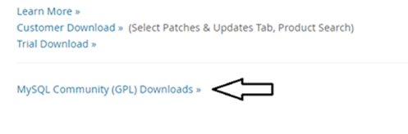

Step 4: Click on MySQL Installer For Windows.

Step 5: Click on the first Download Link.

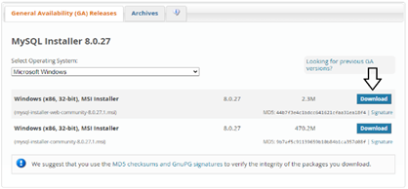

Step 6: Then click, No Thanks, Just Start My Download.

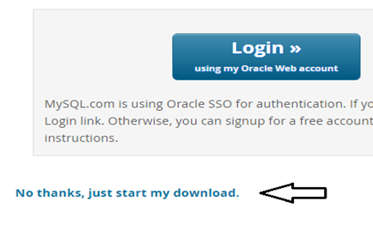

Step 7: Click on All Next……Next… button.

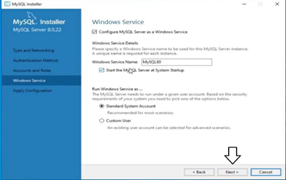

Step 15: Click on Execute.

Step 25: Click on Finish.

Step 26: Click on Next.

Step 27: Click on Finish

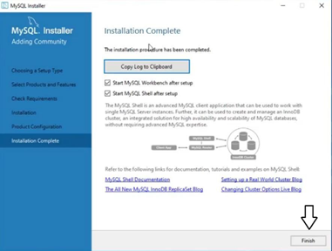

Step 28: Then Automatically MySQL Workbench Window will open.

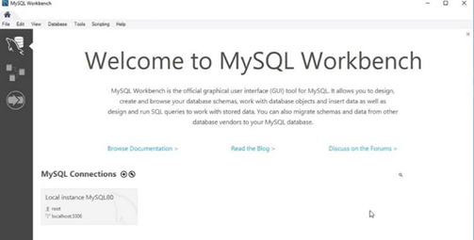

Follow these steps to install in windows

When you open MySQL Workbench for the first time, you'll be prompted to set up a new connection. Enter the necessary information, such as the host, port, username, and password, to connect to your MySQL server. If you're running MySQL on your local machine, the default host is usually "localhost" and the default port is "3306".

Once you've established a connection, you can start using MySQL Workbench to browse your databases, execute queries, manage tables, and perform various other tasks.

**Chapter – 3: Project Management**

**Project Planning**

* Requirement Gathering: Conduct thorough research and gather detailed requirements for the e-commerce website, considering aspects such as product catalo, shopping cart functionality, payment gateways, user registration, security measures, and search engine optimization (SEO).
* Work Breakdown Structure (WBS): Create a WBS to break down the project into manageable tasks, subtasks, and deliverables. Define dependencies and assign responsibilities to team members.
* Project Timeline: Develop a realistic project timeline with clear milestones, task durations, and deadlines. Consider factors such as resource availability, dependencies, and potential risks to create an achievable schedule.
* Resource Allocation: Allocate resources effectively, ensuring that team members have the necessary time, tools, and support to fulfill their assigned tasks. Consider the need for external vendors or contractors if required.

**Communication and Collaboration**

* Communication Plan
* Regular Meetings
* Change Management

**Risk Management**

* Risk Identification
* Risk Assessment and Mitigation:
* Monitoring and Control

**Quality Assurance and Testing**

* Testing Plan: Develop a comprehensive testing plan to ensure the e-commerce website functions as intended
* User Acceptance Testing (UAT): Involve stakeholders and end-users in the UAT process to validate the website's usability, functionality, and user experience.
* Continuous Quality Improvement: Implement processes to monitor and improve the website's performance, security, and user experience even after the launch.

**Launch and Post-Launch Activities**

* Deployment: Coordinate the deployment of the e-commerce website on the chosen hosting platform or server. Ensure a smooth

**Chapter – 4: System Requirement**

**System Requirements for an E-commerce Website**

Developing an e-commerce website requires careful consideration of the system requirements to ensure optimal performance, security, and scalability. Here are some key system requirements to consider:

* Hosting Environment:

Reliable and secure web hosting with sufficient bandwidth and storage capacity to handle website traffic and data storage.

Support for the required programming languages, frameworks, and databases.

Scalability options to accommodate future growth and increased website traffic.

* Operating System:

Choose an operating system that supports the technologies and frameworks you plan to use for website development.

Common choices include Linux-based systems (such as Ubuntu or CentOS) or Windows Server.

* Web Server:

Select a web server software that supports the chosen programming language and framework (e.g., Apache, Nginx, or Microsoft IIS).

Configure the web server for optimal performance, including caching mechanisms and compression settings.

* Programming Languages and Frameworks:

Determine the programming languages and frameworks based on your development preferences and requirements.

Common choices include HTML, CSS, JavaScript for front-end development, and PHP, Python, or Ruby for server-side scripting.

Frameworks like Laravel, Django, or Ruby on Rails provide structure and libraries for efficient development.

* Database Management System (DBMS):

Choose a reliable and scalable DBMS to store and manage product data, user information, and transactional data.

Popular options include MySQL, PostgreSQL, MongoDB, or Microsoft SQL Server, depending on your specific needs.

* Payment Gateways and Security:

Implement secure payment gateway integrations to enable online transactions. Popular options include PayPal, Stripe, or Braintree.

Implement SSL/TLS encryption to ensure secure communication between the website and users, protecting sensitive information.

**Chapter – 5: System Design**

**5.1 Target Users**

The target users of the SF-HRMS project may include:

1. HR Managers: They would use the system to manage and monitor employee information,

attendance, leave, performance, and other related tasks.

2. Employees: They can use the system to check their own attendance, leave balances, pay

stubs, and other personal information.

3. Sales and Marketing Teams: They would use the Sales-Sprout module to manage and

track sales leads, opportunities, and performance.

4. Inventory Managers: They would use the Inventory Management module to monitor and

manage stock levels, orders, and purchase orders.

5. Finance Teams: They would use the Expense Management module to track and manage

expenses, reimbursements, and budgets.

6. Managers and Supervisors: They would use the Schedular module to schedule employee

shifts, assign tasks, and manage workloads.

Overall, the Crowd funding System is designed to cater to

the needs of HR departments, sales and marketing teams, inventory and finance departments,

and managers who need to manage and monitor employee and business-related tasks

efficiently

**5.2 Use Case Diagram**

**Users**

**Admin**

**customer**